Tutorial for Chapter 4

- Memorize the concepts of s- and p-polarized light.

- Familiarize yourself with the Fresnel coefficients.

- A light wave impinges at normal incidence on a thin glass plate with index n and thickness d.
(a) Show that the transmission through the plate as a function of wavelength is
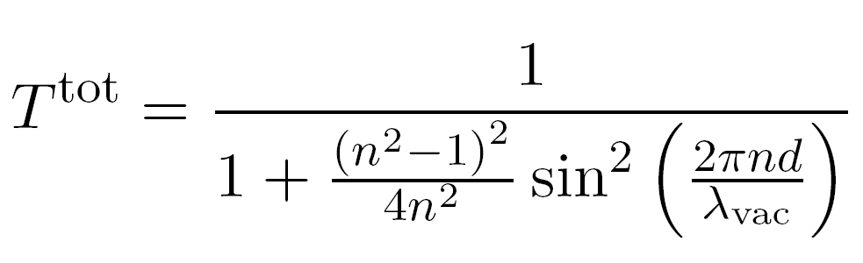

(b) If n = 1.5, what is the maximum and minimum transmission through the plate?
(c) If the plate thickness is d = 300 nm, what wavelengths of visible light transmit with maximum efficiency?

- You desire to make a “beam splitter” for s-polarized light as shown in the figure below by coating a piece of glass (n = 1.5) with a thin film of zinc sulfide (n = 2.32). The idea is to get about half of the light to reflect from the front of the glass. The coating is applied to the front surface of the glass. The light is incident at 45º as shown in the figure. Show that the maximum reflectance possible from the single coating at the first surface is 46%. Find the smallest possible d₁ that accomplishes this for light with wavelength λ_{vac} = 633 nm.

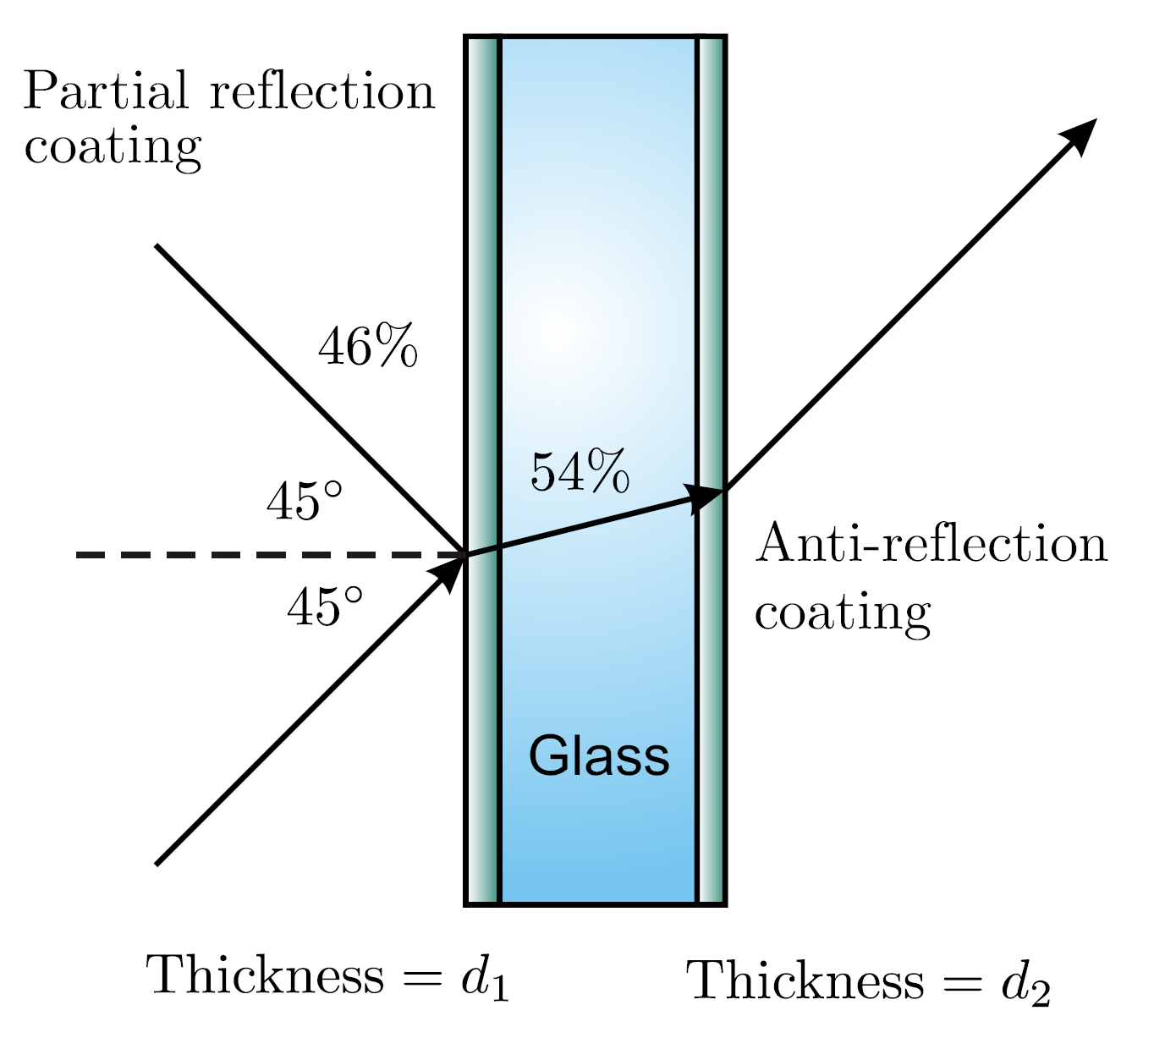
- This is a continuation of the previous problem. Find the highest transmission possible through an antireflection coating of magnesium fluoride (n = 1.38) at the back surface of the “beam splitter”. Find the smallest possible d₂ that accomplishes this for light with wavelength λ_{vac} = 633 nm.

- Re-compute (4.33) in the case of s-polarized light. Write the result in the same form as the last expression in (4.33). HINT: You need to redo (4.29)–(4.31).

- A Fabry-Perot interferometer has silver-coated plates each with reflectance R = 0.9, transmittance T = 0.05, and absorbance A = 0.05. The plate separation is d = 0.5 cm with interior index n_{m} = 1. Suppose that the wavelength being observed near normal incidence is 587 nm.
(a) What is the maximum and minimum transmission through the interferometer?
(b) What are the free spectral range Δλ_{FSR} and the fringe width Δλ_{FWHM}?
(c) What is the resolving power?

- Consider the configuration depicted in the figure below, where the center of the diverging light beam λ_{vac} = 633 nm approaches the plates at normal incidence. Suppose that the spacing of the plates (near d = 0.5 cm) is just right to cause a bright fringe to occur at the center. Let n_{m} = 1. Find the angle for the m_{th} circular bright fringe surrounding the central spot (the 0th fringe corresponding to the center). HINT: $\text{cos}θ≈1−\frac{θ^{2}}{2}$. The answer has the form $a\sqrt{m}$; find the value of a.

