Tutorial for Chapter 6

- Understand the concept of the paraxial approximation.

- Understand on how to apply the ABCD matrices (6.7), (6.17) and (6.22) to compute the displacement and angle of the ray after propagating a distance of d, reflecting by a curved mirror, and transmitting through a curved interface, respectively.

- Memorize the condition for imaging formation (6.28).

- Memorize the ABCD matrices for a thin lens (6.33).

- Memorize the definitions (6.40), (6.41) and (6.42) for the effective length and the two principal planes.

- Derive the ABCD matrix that takes a ray on a round trip through a simple laser cavity consisting of a flat mirror and a concave mirror of radius R separated by a distance L. HINT: Start at the flat mirror. Use the matrix in (6.7) to travel a distance L. Use the matrix in (6.17) to represent reflection from the curved mirror. Then use the matrix in (6.7) to return to the flat mirror. The matrix for reflection from the flat mirror is the identity matrix (i.e. R_{flat} → ∞).

- Derive the ABCD matrix for a thick lens made of material n₂ surrounded by a liquid of index n₁. Let the lens have curvatures R₁ and R₂ and thickness d.

- Consider a lens with thickness d = 5 cm, R₁ = 5 cm, R₂ = −10 cm, n = 1.5. Compute the ABCD matrix of the lens.

- Referring to the above question, where are the principal planes located? And what is the effective focal length f_{eff} for this system?

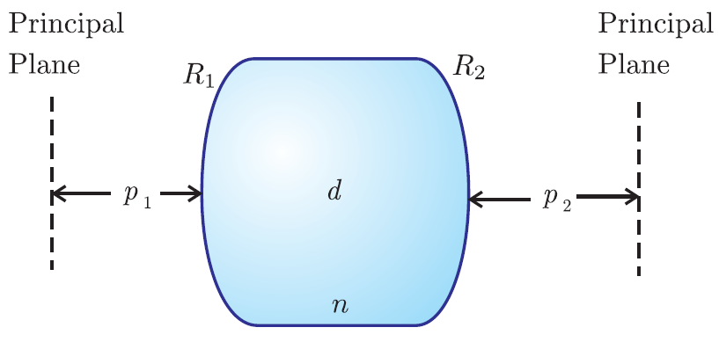
9. Show that the ABCD matrix for a thick lens reduces to that of a thin lens (6.33) and (6.34) when the thickness goes to zero. Take the index outside of the lens to be n₁ = 1.

10. Find the ABCD matrix for a thick window (thickness d). Take the index outside of the window to be n₁ = 1. HINT: A window is a thick lens with infinite radii of curvature.

11. An object is placed in front of a concave mirror. Find the location of the image d_{i} and magnification M when d_{o} = R, d_{o} = R/2, d_{o} = R/4, and d_{o} = −R/2 (virtual object).

12. A complicated lens element is represented by an ABCD matrix. An object placed a distance d₁ before the unknown element causes an image to appear a distance d₂ after the unknown element.

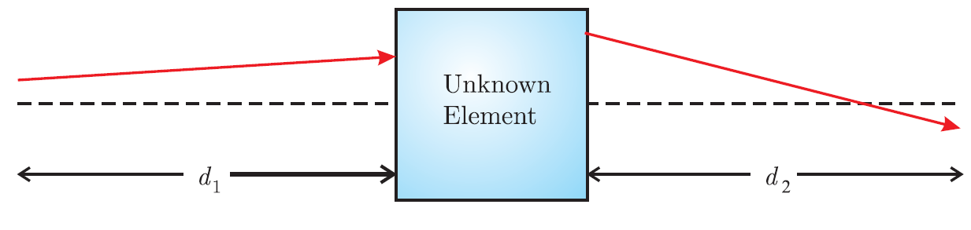

Suppose that when d₁ = a, we find that d₂ = 2a. Also, suppose that when d₁ = 2a, we find that d₂ = 3a/2 with magnification −1/2. What is the ABCD matrix for the unknown element?
HINT: Use the conditions for an image (6.37) and (6.38). If the index of refraction is the same before and after, then (6.44) applies. First find linear expressions for A, B, and C in terms of D. Then put the results into (6.44).

