Tutorial for Chapter 7

1. Show that $E(r)=E_{0}r_{0}{e^{\text{ikr}}}/r$, where E₀ and r₀ are constants, is a solution to the scalar Helmholtz equation (7.6). Hint:
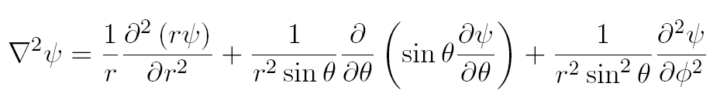

2. Learn by heart the derivation of the Fresnel-Kirchhoff diffraction formula under the paraxial wave approximation.

3. Apply the Fresnel-Kirchhoff diffraction formula (7.1) to a monochromatic plane wave with intensity I₀, which goes through a circular aperture of diameter $ℓ$ Find the intensity of the light on axis (i.e. x, y = 0). HINT: The integral takes on the following form:
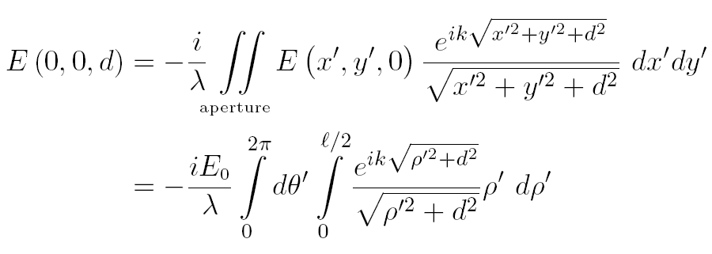
Then you will want to make the following change of variables:$ξ≡\sqrt{ρ'^{2}+d^{2}}$.
This will make it easier to accomplish the integration.

4. Subtract the field found in Question 3 above from a plane wave field E₀e^{ikd} to obtain the on-axis field behind a circular block. Show that the intensity on axis behind the circular block is constant (i.e. independent of d) and is equal to the intensity of the initial plane wave.

5. Repeat Question 3 to find the on-axis intensity after a circular aperture in the Fresnel approximation. HINT: You can make a suitable approximation directly to the answer of Question 3 to obtain the Fresnel approximation. However, you should also perform the integration under the Fresnel approximation for the sake of gaining experience.

6. Repeat Question 3 (or Question 5) to find the on-axis intensity after a circular aperture in the Fraunhofer approximation. HINT: You can make a suitable approximation directly to the answer of Question 5 to obtain the Fraunhofer approximation. However, you should perform the integration under the Fraunhofer approximation for the sake of gaining experience.

